 GREATEST WAR GENERALS
IN HISTORY

1.Requirements and Specifications

Project Overview
This document outlines the complete planning and design process for a website dedicated to the greatest war generals in history. The website was created using front-end web technologies including HTML5, and CSS.
The website was developed to improve user interaction with historical content by presenting information in a visually attractive and responsive manner. The website is a combination of profiles, images and historical information, and will serve as an information and educational resource that honors military commanders.
According to Principles of Web Design - 6th Edition – By Joel Sklar , responsive web design improves readability for users and improves accessibility across multiple screen sizes and devices such as tablets and mobile phones. This principle was adhered throughout the development of this website.

Project Goals
- Provide an engaging, historical, accurate reference for military history enthusiasts.

- Educate users about famous military leaders that have come and gone over the years.

- Improve user interaction through easy navigation.

- Ensure the website is responsive and accessible to users with different devices, such as desktop, mobile, and tablet.

- Show case skills of web development

Target audience

The target audience mainly consists of:

- Secondary school students
- University/Collage students
- Teachers
- Researchers
- History enthusiasts

Category | Details
Age group | 15-50
Gender | All genders
Level of education | Secondary – university/collage
Location | Global

Technical Aptitude

The users that are going to access this website are expected to have:
- Basic noncomplex internet navigation skills
- The ability to use a mobile phone, tablet or desktop
2.Information Design & Taxonomy

This website was designed with a simple and easily accessible navigation structure , it follows the three click rule, which states that users must be able to fimd important information within three clicks.

Site map:
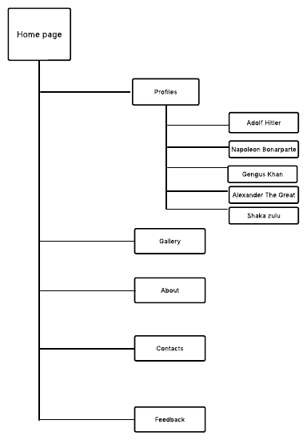Navigation paths
The navigation bar is visible throughout the pages of the website , for easy accessibility and also provides a way back for users.

3.Page Template Design
Design Overview
The website uses a dark theme, and focuses on offering simplicity, readability, it has a lot of active white spaces and a responsive structure.

Home page layout
The home page contains :
- Navigation bar
- Header section
- Landing banner
- Featured general section
- Information section
- Footer section

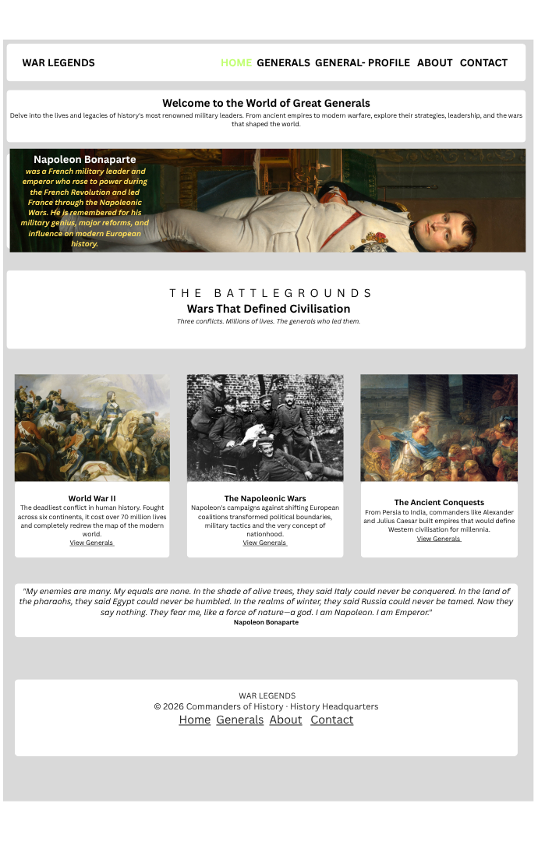
Gallery Page Layout
The gallery page uses a responsive grid layout to display historical images.
The page contains:
- Category filter buttons.
- Image grid.

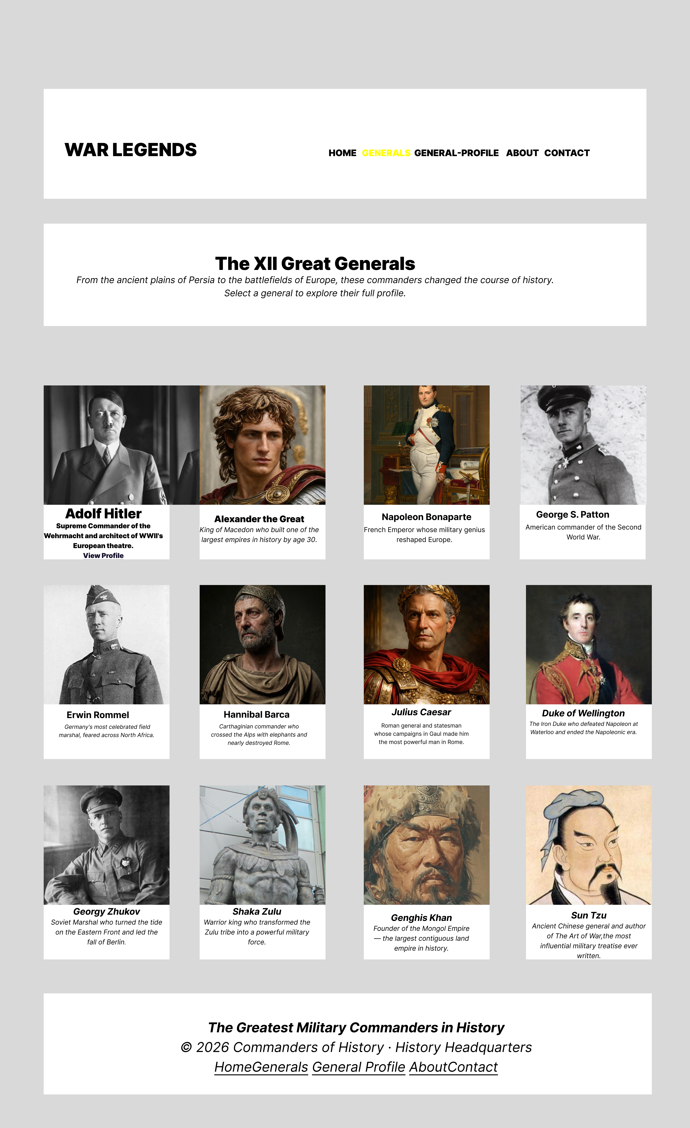
Profiles Page Layout
The profiles page displays generals using profile cards.
Each profile card contains:
- Historical image.
- Name.
- Nationality.
- Historical era.
- Short description.
- View Profile button.

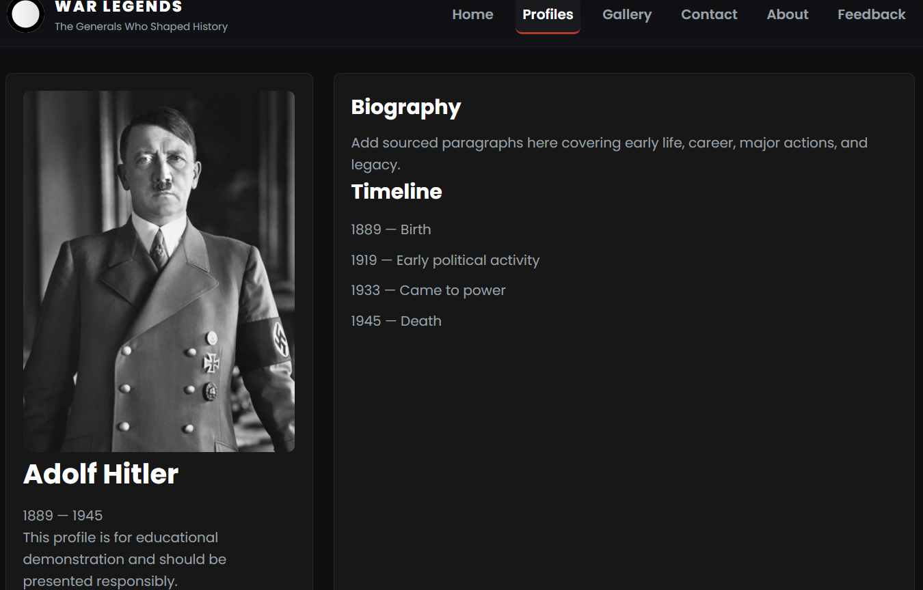

Contact Page Layout
The contact page includes:
- Contact information.
- Social media links.
- Contact form.
Users can enter their:
  - Name
  - Email address
  - Subject
  - Message they wish to send

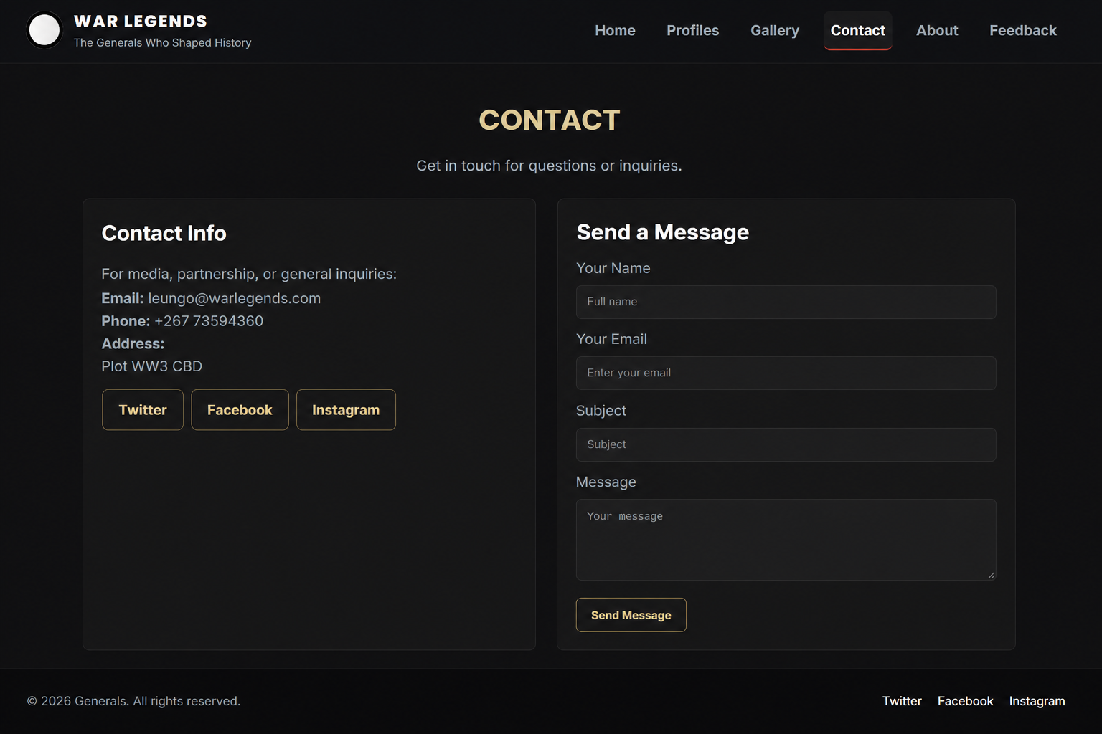

Feedback Page Layout
The feedback page contains:
- Feedback form.
- Rating system.
- Feedback information.
The rating system allows users to rate the website using stars.

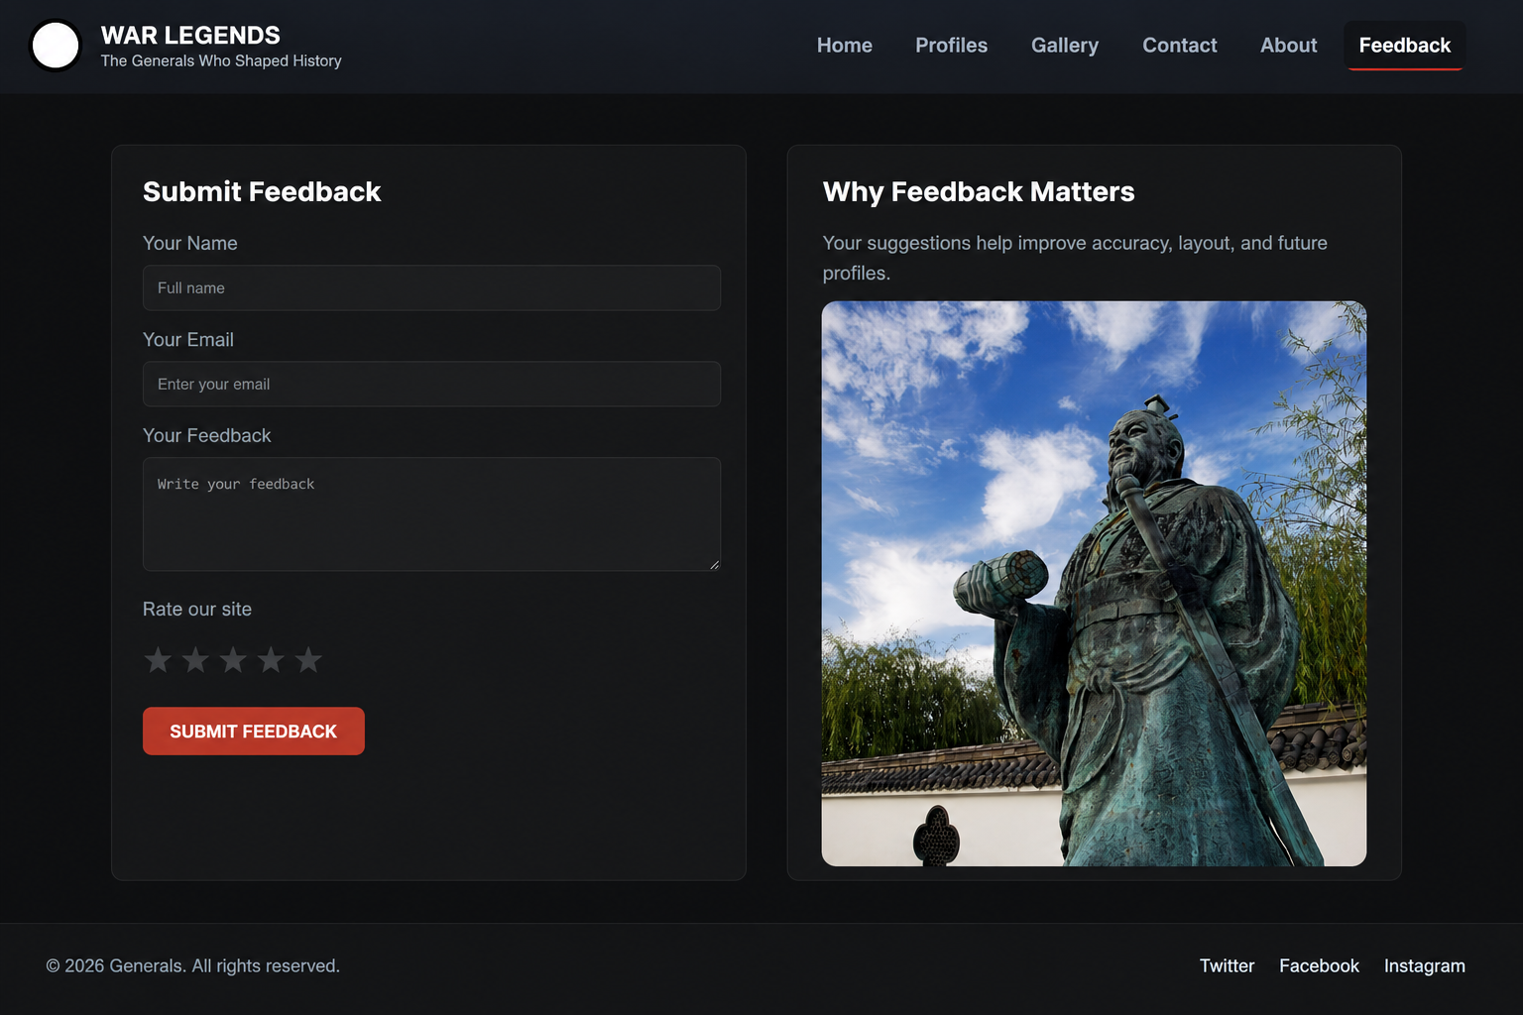

4.Technical brief

- I will be using HTML5 which uses semantic elements such as <header>, <nav>, <section> etc, and CSS to style my layouts.
- JavaScript
JavaScript was used to:
- Control the mobile navigation menu.
- Toggle navigation visibility on smaller screens.
- Improve interactivity.
- Example functionality includes:
- Navigation toggle button.
- Responsive mobile menu.

- For my code editor, i chose to go with Visual Studio Code.It is a very powerful developer tool, which allows us to detect syntax errors, you can install a live server to see changes in real time.
- Google chrome to view my website
- Google fonts for improved typography
- Git Hub for version control and hosting.

5.QUALITY ASSURANCE

Browser Compatibility Testing:
The website was tested on different browsers to ensure compatibility

This test was on Google chrome, the page is running well with no issues.

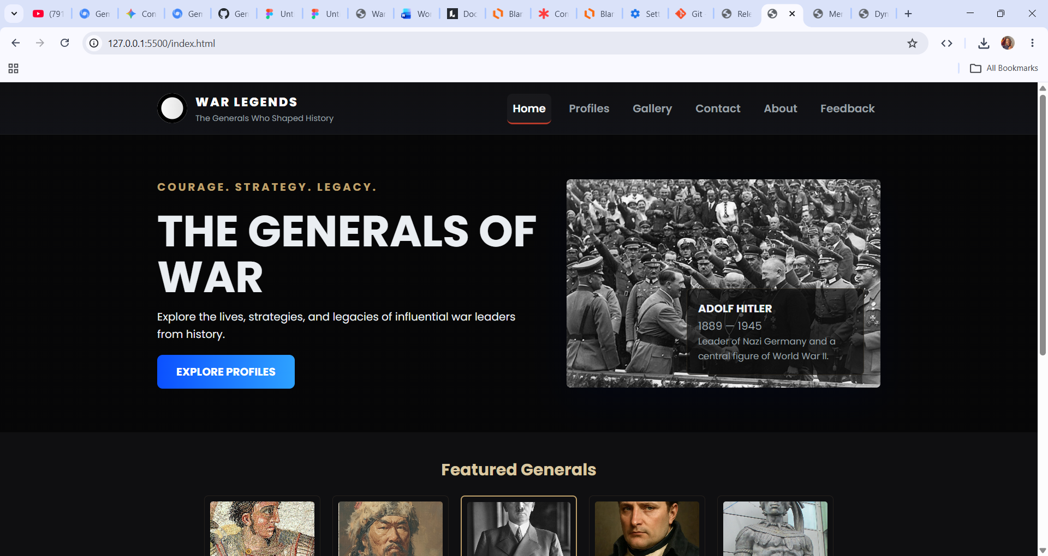

This test was on Microsoft Edge, the page is running well with no issues

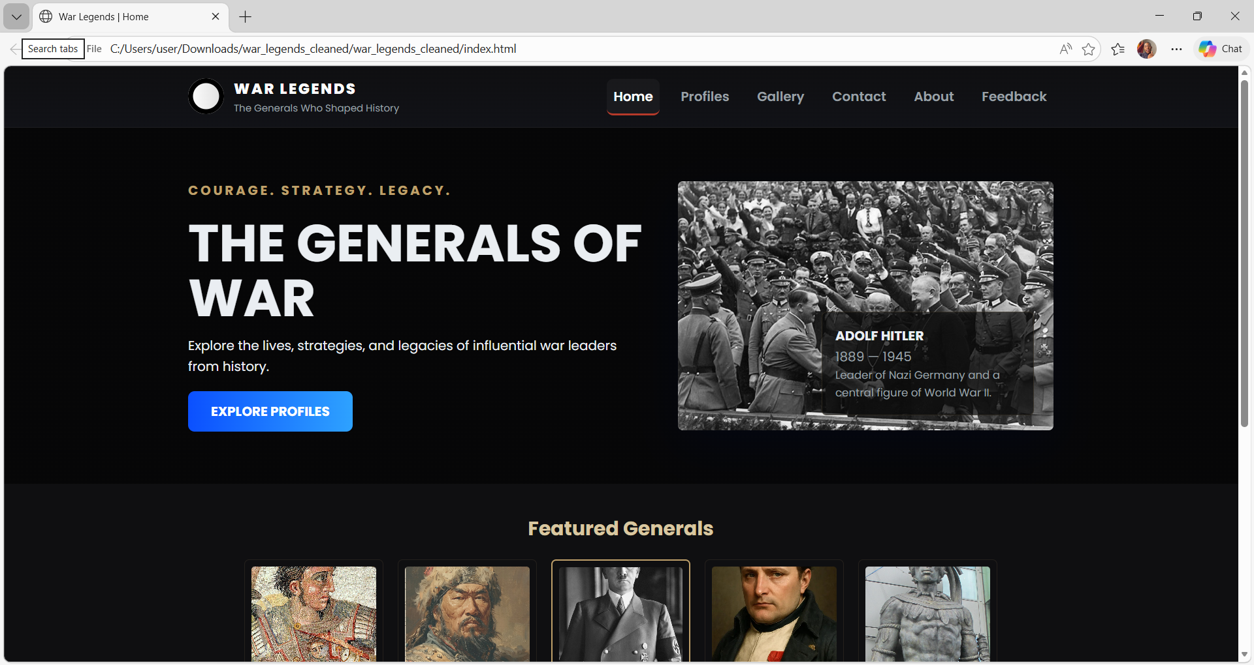

Mobile Device Testing
To ensure compatibility with different devices, we tested on multiple devices

This was tested on an iPad
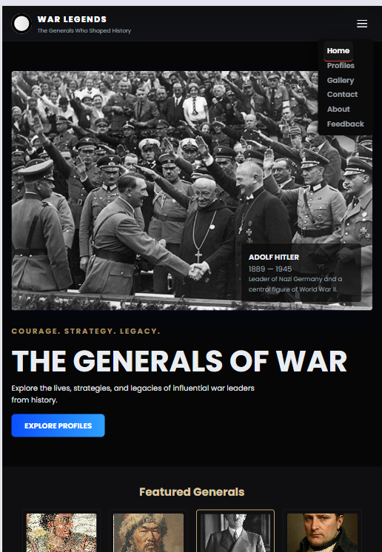

This was tested on a Sumsung Galaxy S20
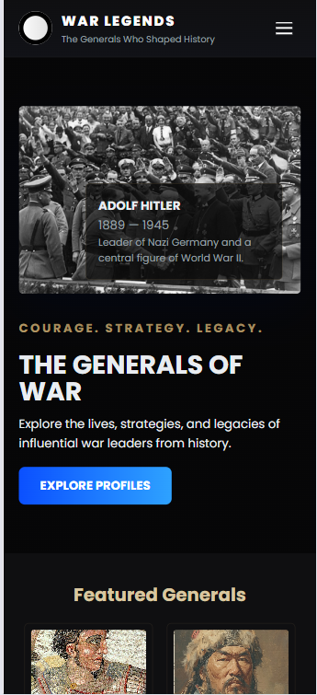

We added a drop down navigation bar for mobile devices and tablets, for easy accessibility.
This was tested on a DELL desktop


Website Speed Tests
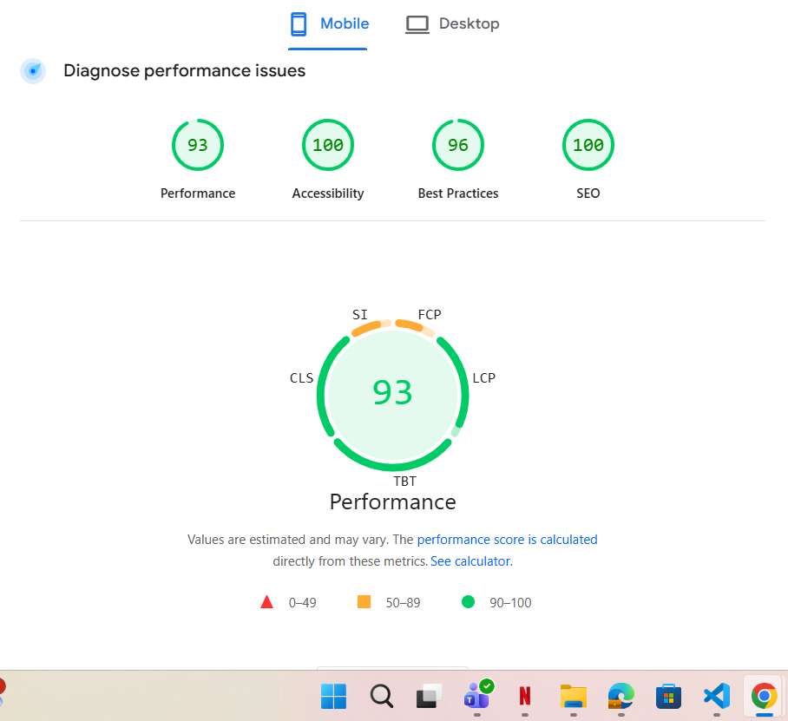

7.PUBLISHING & PROMOTION

Hosting Method
The website was hosted on GitHub pages.

GitHub Repository setup
The project files were uploaded on GitHub repository.
These are the Git commands that were used :
Initialize Repository
Git init
Add Files
Git add
Commit Changes
Git commit -m “Initial website upload”
Connect Remote Repository
git remote add origin https: //github.com /MGTONBOARD/REPOSITORY.git
Push Files to GitHub
git push -u origin main

Promotion Methods
The website can be promoted on:
- GitHub portfolio sharing
- Social media

8.Future Developments
The website can be improved further by adding:

- Dark and light mode switching.
- Video and audio historical media.
- Dynamic loading of content.
- Accessibility improvements.
- Online admin dashboard.
- Multi-language support

Conclusion
This website demonstrates the use of HTML5, CSS3 and java script in making the responsive website.
We were able to achieve its main goals by providing
- Organized text
- Flexible navigation
- Responsive layout
The project includes profiles pages, image gallery , proper navigation, and responsive features.
Although some features are not fully functioning and under construction the website provides a foundation for future developments.

